Enclosure Assembly Instructions
- First, use four M3*5 round head screws to fix the PCB onto the enclosure. Then assemble the waterproof connectors on the enclosure and connect the wires between the PCB and the connectors.
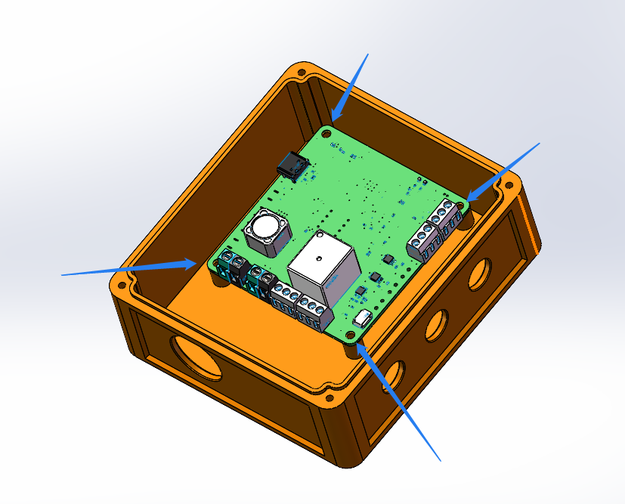
- Then use three M3*10 self-tapping screws to secure the upper cover.
